UNIVERSITI TEKNOLOGI PETRONAS

MAY 2026 SEMESTER



TFB3133
Data Visualization
Lecturer’s Name: Dr. Ganesh Kumar
Lab 09
Developing Interactive Dashboard

Lab Group G8

Project Title: E-Commerce Performance Dashboard

No. | Name | Student ID | Course
2 | Ameer Edzzad Shah bin Ahmad Shah | 22005680 | Bachelor of Information Technology (Hons.)

E-Commerce Performance Dashboard

1. Domain and Problem Definition
Domain: E-Commerce
Problem Statement:
This project investigates how a UK-based online gift retailer can convert two years of raw, transaction-level sales data (1,067,371 raw records, cleaned to 1,027,017) into actionable insight. Currently, the business has no consolidated view of which products and markets drive revenue, how sales behave over time, or which transactions represent risk (returns, cancellations, pricing anomalies). Decisions about inventory, marketing spend, and market expansion are effectively made without visibility into patterns already present in the data.
Why it matters: Revenue is heavily concentrated — the United Kingdom accounts for approximately 91.9% of all transactions (944,046 of 1,027,017 rows), while 42 other countries share the remainder. Without a dashboard, the business risks over-investing in an already-saturated market while overlooking smaller but potentially faster-growing markets (Germany, France, Netherlands rank next by volume).
Who uses the dashboard: Senior Manager, Sales/Marketing Analyst, Inventory/Operations Staff (full detail in Section 3).
Decisions supported: where to focus marketing budget, whether top-selling products are adequately stocked, whether rising returns signal a quality/pricing/fulfilment problem, and whether seasonal patterns should inform stock timing.
Risk of misinterpretation: treating large wholesale orders as "outliers to ignore" would understate true revenue drivers (many customers in this dataset are wholesalers); treating UK dominance as the only signal worth acting on could cause smaller growing markets to be deprioritized; ignoring the 22.3% of transactions with missing Customer_ID would silently exclude a meaningful share of real sales from any customer-level conclusion.

2. Dataset Description
Source: UCI Machine Learning Repository — Online Retail II (Chen, 2012), https://archive.ics.uci.edu/dataset/502/online+retail+ii
Description: Transaction-level sales data from a UK-registered, non-store online retailer selling all-occasion gift-ware, covering 1 December 2009 to 9 December 2011. Many customers are wholesalers, meaning single transactions can include bulk quantities.
Original size: 1,067,371 rows, 8 columns
Cleaned size: 1,027,017 rows, 21 columns (8 original + 13 engineered/cleaned)
Original attributes: Invoice, StockCode, Description, Quantity, InvoiceDate, Price, Customer ID, Country
Engineered attributes: Revenue, Order_Size_Category, Price_Tier, Has_Customer_ID, IsReturn, Year, Month, MonthName, Weekday, Hour, YearMonth, Price_Outlier, Quantity_Outlier
This satisfies the assignment's minimum dataset requirements: >500 records, 6+ attributes, 2+ categorical (Country, Order_Size_Category, Price_Tier), 2+ numerical (Quantity, Price, Revenue), and a date attribute (InvoiceDate).

3. Stakeholder Requirements
Stakeholder | Main Objective | Required Information | Detail Level | Interactions | Limitations
Senior Manager | Understand overall business health at a glance | Total revenue, trend, top countries/products, return rate | Summary | Date range filter, country filter, KPI cards | Limited time; needs headline numbers and warnings, not raw tables
Sales/Marketing Analyst | Identify which products, price tiers, and countries drive or drag down revenue | Revenue by product/category, price-tier breakdown, country comparisons, order-size distribution | Detailed | Drill-down country → customer, cross-filtering, sorting, product search | Comfortable with data but needs to isolate segments quickly
Inventory/Operations Staff | Spot unusual transactions needing follow-up | Return/cancellation rate over time, outlier-flagged transactions, order-level detail | Both | Filter by date/product, view flagged records, reset control | May not interpret raw statistics (e.g. IQR bounds); needs plain flags

4. Analytical Questions
Descriptive
- Which product categories/descriptions generate the highest total revenue, and how concentrated is revenue among the top few products?
- What is the average order value overall, and how does it differ across the top countries by transaction volume?
Comparative
3. How does total revenue from the United Kingdom compare to the combined revenue of the next five highest-performing countries?
4. Do "Large" orders (20+ units) contribute a disproportionately large share of revenue relative to how often they occur, compared to "Small"/"Medium" orders?
Trend
5. How has monthly revenue changed across the two-year period, and is there a recurring seasonal pattern?
6. Has the rate of returns/cancellations increased, decreased, or stayed stable over the period?
Relationship
7. Is there a relationship between a product's unit price and the quantity typically purchased per transaction?
Anomaly/Risk
8. Which countries or products show an unusually high proportion of outlier-flagged transactions or high return rates, warranting investigation?

5. Data-Cleaning Summary
Metric | Value
Original rows | 1,067,371
Rows removed — missing Description | 4,382 (0.41%)
Duplicate rows removed | 34,228
Rows removed — invalid price (≤0, non-return) | 1,744
Final cleaned rows | 1,027,017
Missing Customer_ID (retained, flagged) | 229,202 (22.3%)
Price outliers (retained, flagged, IQR method) | 66,191 (6.4%)
Quantity outliers (retained, flagged, IQR method) | 111,527 (10.9%)
Date range | 1 Dec 2009 – 9 Dec 2011
Countries | 43
Unique products | 4,932
Unique customers | 5,939
Key decisions and justification:
- Missing Customer_ID rows were kept (not deleted) because they represent real guest/unregistered sales; deleting them would understate total revenue. A Has_Customer_ID flag preserves transparency.
- Outliers were flagged, not removed, because large-quantity orders are legitimate wholesale activity for this retailer, not necessarily errors.
- Country names were standardized (trimmed, title-cased) to prevent the same country being split into multiple categories by casing/spacing differences.
- Rows with Price ≤ 0 on non-return transactions were removed as data-entry errors, since a genuine sale cannot have zero or negative value.
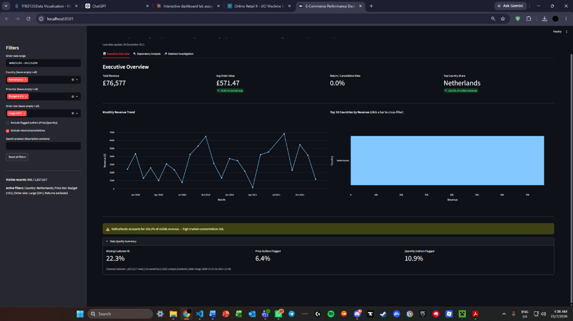
Figure 1: Data Quality Summary expander

6. Visualization Selection and Justification
Chart | Type | Answers Question(s) | Why this chart
Monthly revenue trend | Line chart | Q5 | Line charts are the standard for showing continuous change over time and make seasonal spikes visually obvious
Top 10 countries by revenue | Horizontal bar chart | Q1, Q3 | Bars allow direct ranking comparison across many categories; horizontal orientation keeps long country names readable
Price vs Quantity | Scatter plot (bubble = Revenue) | Q7 | Scatter is the only chart type that shows the relationship between two continuous variables directly, with bubble size adding a third dimension (Revenue)
Revenue by Order Size Category | Box plot | Q4 | Box plots show median, spread, and outliers simultaneously across categories — more informative than a bar chart's single average
Country → Order Size composition | Treemap | Q1, Q4 | Treemaps show hierarchical part-to-whole relationships proportionally, which a pie chart cannot do with more than a handful of categories
Weekday × Hour heatmap | Heatmap (advanced) | Q5 | Encodes two categorical dimensions plus a continuous value in one view — would require 7 separate line charts otherwise
Country → Price Tier → Order Size | Sunburst (advanced) | Q1, Q4 | Displays a 3-level hierarchy in one chart; a stacked bar chart cannot cleanly represent 3 nested levels
Revenue by country | Choropleth map (advanced) | Q1, Q3, Q8 | Geographic concentration is inherently spatial — a map shows regional clustering (e.g. Western Europe) that a ranked bar chart cannot
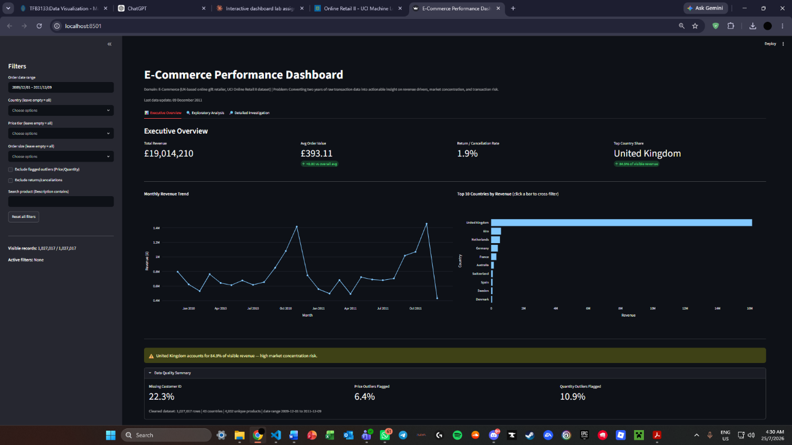
Figure 2: Executive Overview full view
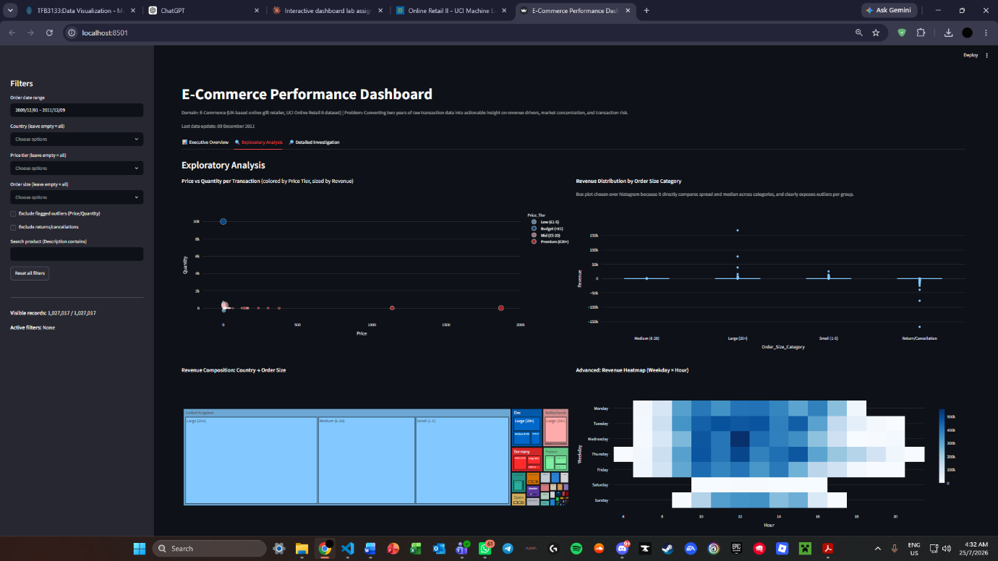
Figure 3: Scatter + box plot + Treemap + heatmap

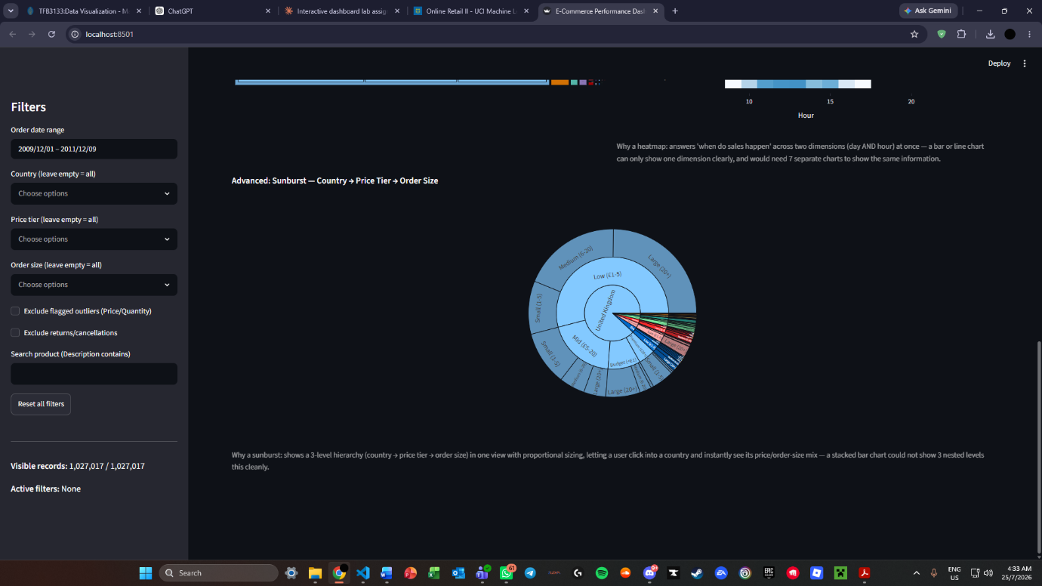
Figure 4: Sunburst

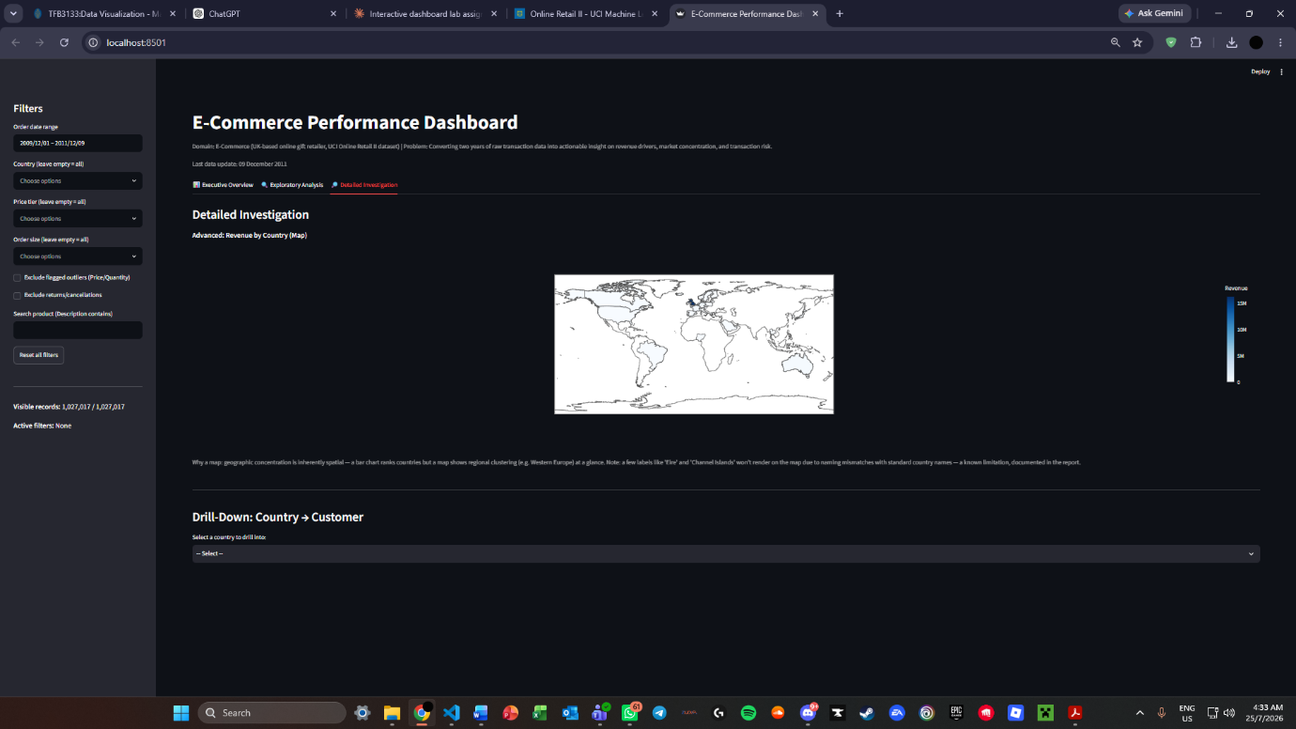

Figure 5: Choropleth map

7. Interaction Design
# | Interaction | Where | Purpose
1 | Country / price tier / order size filtering | Sidebar (all views) | Category filtering (Task 7.1)
2 | Date range picker | Sidebar (all views) | Time-range filtering (Task 7.2)
3 | Hover tooltips | All charts | Details-on-demand without cluttering the chart
4 | Click-to-highlight on country bar | Executive Overview | Highlights selected country, visually distinct from others
5 | Cross-filtering | Executive Overview | Clicking a country bar filters KPI cards and the trend chart simultaneously — the "Cross-Filtering Challenge"
6 | Drill-down (Country → Customer) | Detailed Investigation | 2-level drill-down with "back" navigation
7 | Product search | Sidebar | Dynamic search by product description
8 | Reset filters button | Sidebar | Clears all filters and drill-down state in one action
Active filters, number of visible records, and the currently selected drill-down level are always visible in the sidebar and view headers, satisfying the requirement for clear filter-state indication.
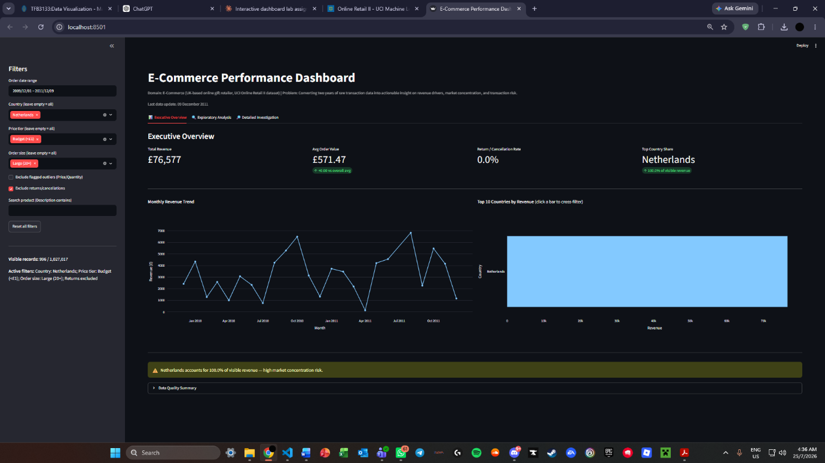
Figure 6: Sidebar with filters applied

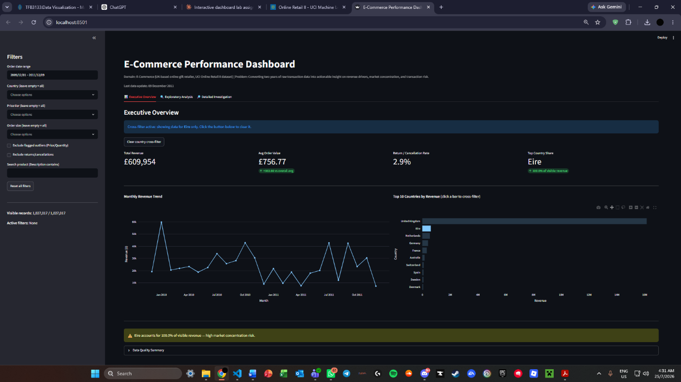
Figure 7: Executive Overview with cross-filter active
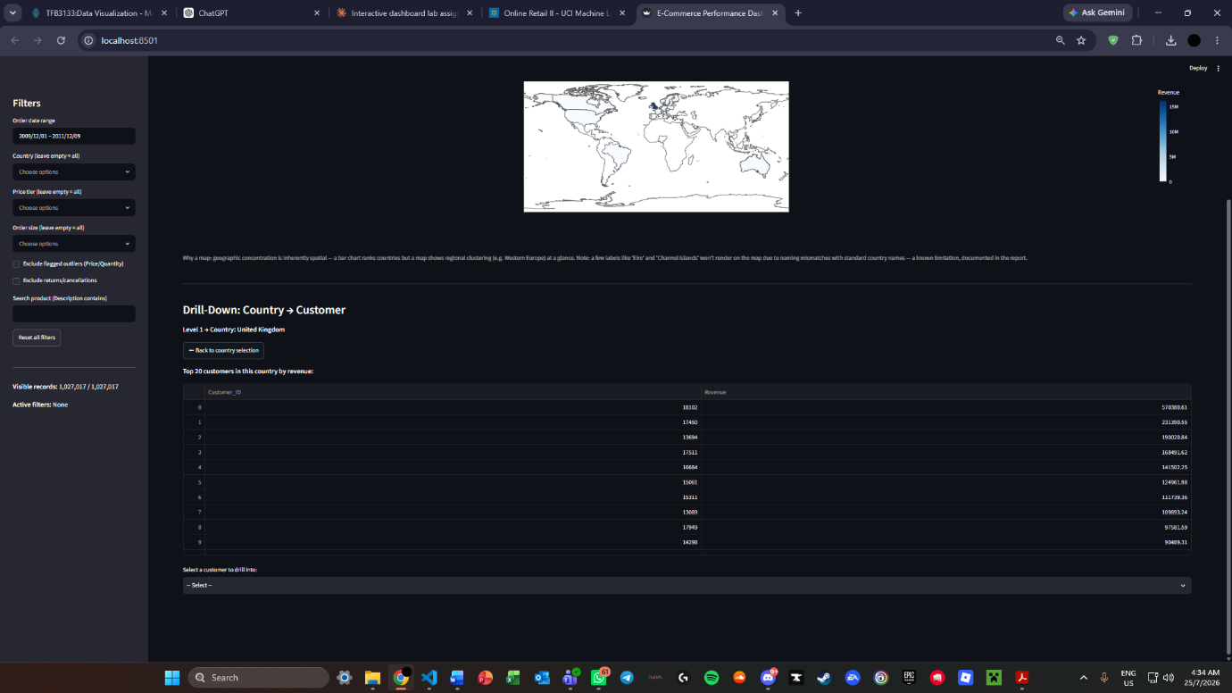
Figure 8: Drill-down Level 1

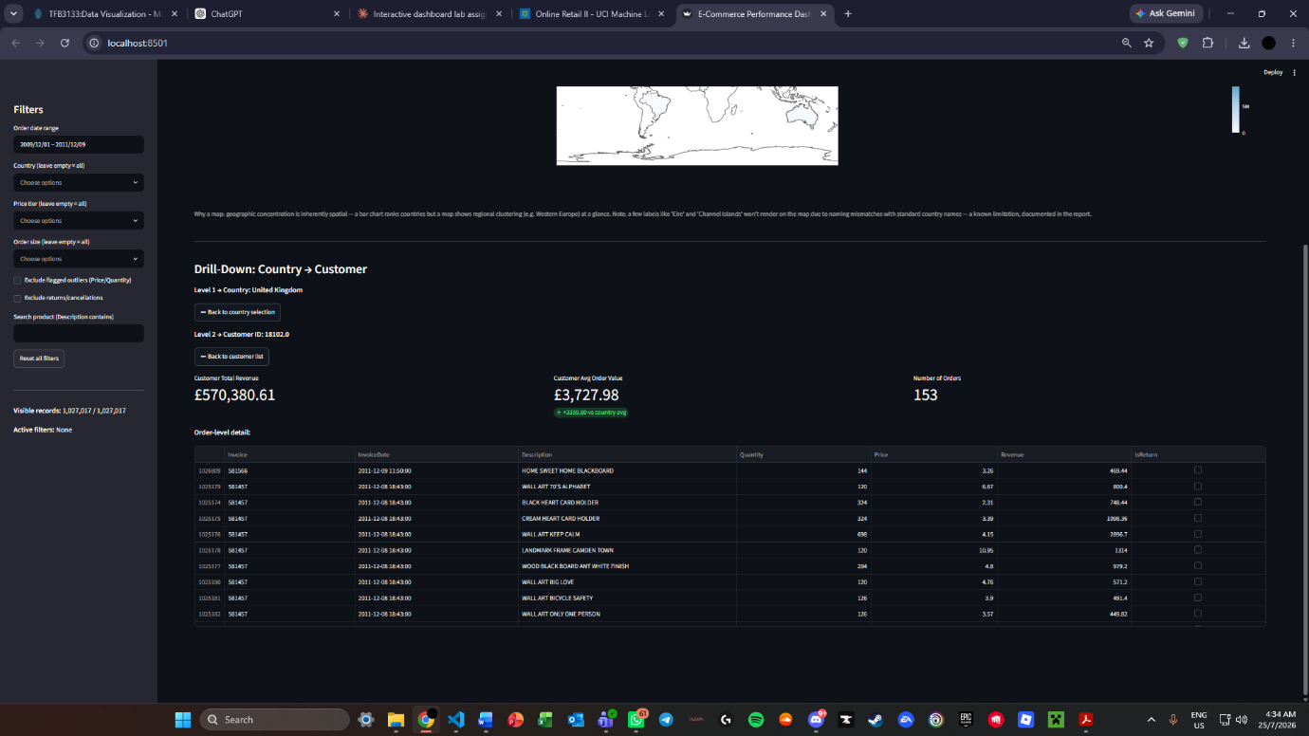
Figure 9: Drill-down Level 2

8. Key Insights and Recommendations
(Fill in the bracketed numbers by reading them off your live dashboard once it runs cleanly — I've grounded everything I can in numbers already confirmed from your cleaning script output.)
Insight 1 — Context: The business operates across 43 countries, but the UK alone accounts for 91.9% of transaction volume (944,046 of 1,027,017 records), visible on the Top 10 Countries bar chart and the choropleth map.
Insight 2 — Pattern: [Referencing the Monthly Revenue Trend chart] Revenue shows a recurring spike in [check your chart — likely November/December, consistent with gift-retail seasonality]. Note the exact month(s) and % increase from your live trend line.
Insight 3 — Explanation: The Nov/Dec spike (if confirmed) is consistent with holiday gift-buying behavior, given the retailer's stated focus on "all-occasion gift-ware."
Insight 4 — Risk: 22.3% of transactions have no linked Customer_ID, meaning any customer-level segmentation or loyalty analysis is built on roughly three-quarters of the true customer base — a significant blind spot for retention strategy.
Insight 5 — Risk/Opportunity: [Referencing the Box Plot by Order Size Category] "Large" orders (20+ units) show [check median/spread from your chart] — if their median revenue per order substantially exceeds Small/Medium orders, this confirms wholesale customers are a disproportionately valuable segment worth a dedicated account strategy (Recommendation).
Insight 6 — Anomaly/Risk: [Referencing the Return Rate KPI] The overall return/cancellation rate is [X]% (read this directly from your Executive Overview KPI card). If above ~5%, flag which countries or products (via the Detailed Investigation drill-down) show disproportionately high return rates, as this may indicate pricing errors or product quality issues rather than normal customer behavior.
Insight 7 — Opportunity: [Referencing the Top 10 Countries chart] Germany, France, and the Netherlands rank as the top non-UK markets by volume. Given their far smaller current share relative to the UK, targeted marketing spend in these three markets — rather than further UK-focused campaigns — represents the highest-leverage growth opportunity (Recommendation).
Actionable recommendations (3 minimum, marked above):
- R1: Develop a dedicated wholesale/bulk-order account strategy given the outsized value of Large orders (Insight 5)
- R2: Reallocate a portion of marketing budget toward Germany, France, and Netherlands rather than further UK saturation (Insight 7)
- R3: Investigate the root cause of returns in the highest-return-rate country/product segment identified via drill-down, rather than treating the return rate as a single aggregate number (Insight 6)

9. Ethical Considerations
- Customer privacy: Customer_ID, while pseudonymized (numeric, no names), combined with country and purchase history could still enable re-identification of individuals in low-volume countries with very few customers. The dashboard should not be distributed outside authorized business roles.
- Fair interpretation of return-rate data: Using return rate to evaluate specific products or countries risks unfairly penalizing a market or product line based on incomplete context (e.g. shipping damage vs. genuine dissatisfaction). Return-rate insights should trigger investigation, not automatic punitive action.
- Data completeness bias: Because Customer_ID is missing for 22.3% of transactions, any customer-facing decision (e.g. loyalty targeting) built solely from Customer-linked data would systematically exclude guest purchasers, which could bias marketing decisions toward already-registered customers.

10. Limitations
- The dataset is heavily UK-skewed (91.9% of transactions), limiting the statistical reliability of conclusions drawn about smaller markets with far fewer data points.
- Country choropleth map cannot render a small number of entries ("Eire," "Channel Islands," "Unspecified") due to naming mismatches with standard geographic naming conventions used by the mapping library.
- The dataset lacks delivery/shipping timestamps, customer demographic data, and marketing channel data, meaning root causes behind trends (e.g. why returns rose in a given month) can be flagged but not conclusively explained from this data alone.
- Outlier flags use a purely statistical method (IQR); they indicate unusualness, not confirmed errors, and should be treated as a starting point for investigation rather than a verdict.


Figure 10: Choropleth map

